FRONT-END PROGRAMMING CSM3103



UNIVERSITI MALAYSIA TERENGGANU

LAB MODULE 4

NAME : ILHAM HANINA MADIHA BINTI OTHMAN

MATRIC NO : S63762

PROGRAMME: BACHELOR OF COMPUTER SCIENCE (MOBILE COMPUTING)

LECTURER : DR RABIEI B MAMAT

GITHUB LINK : <https://github.com/ilhamhanina/Code-Lab-CSM3103-S63762.git>

Task 1

1. i. What is the id of button

id button = button_change

1. ii. What happened when you clicked change button and why?

Nothing happen and the title didn’t change.

1. Your mission: when the button is clicked, all occurrences of the word Black to be changed to the text in the input field.

Output for Task 1:-

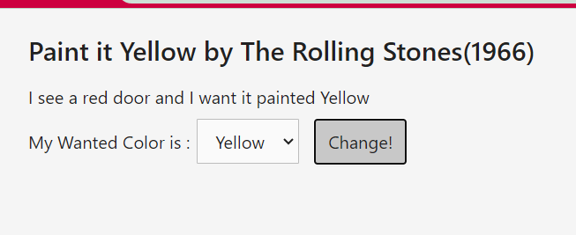

The codes:-

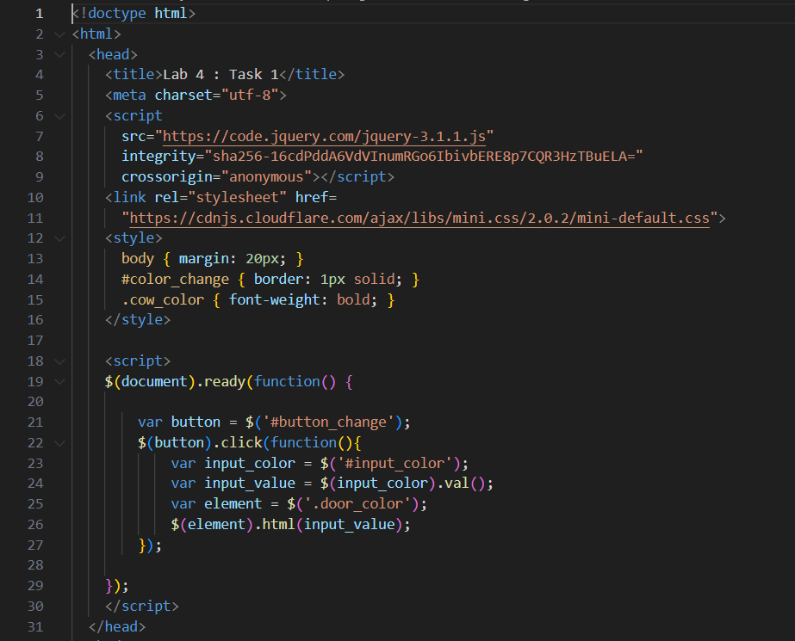

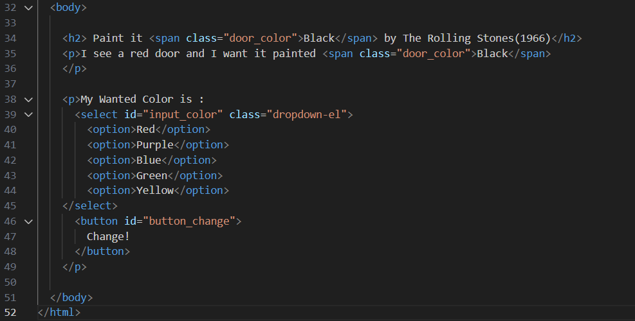

Task 2

The output-

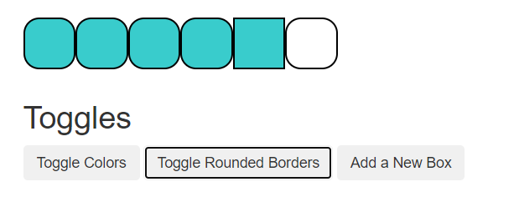

The codes:-

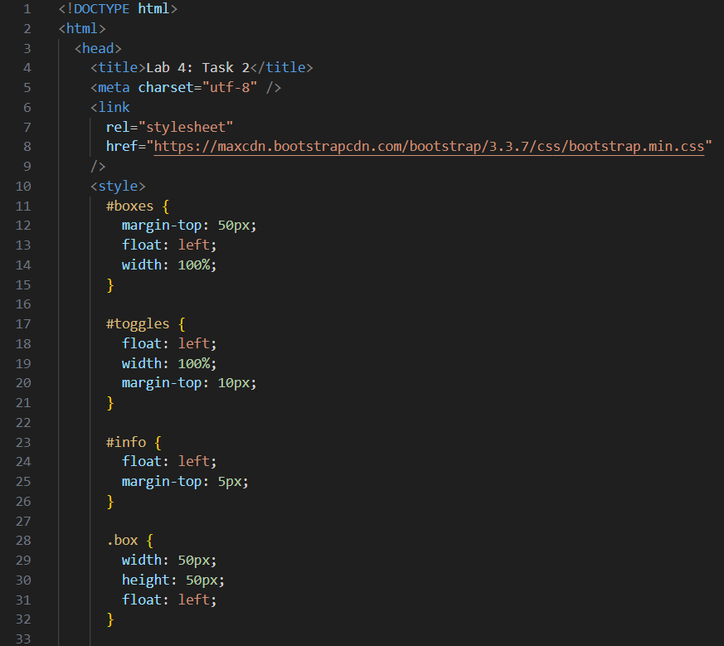

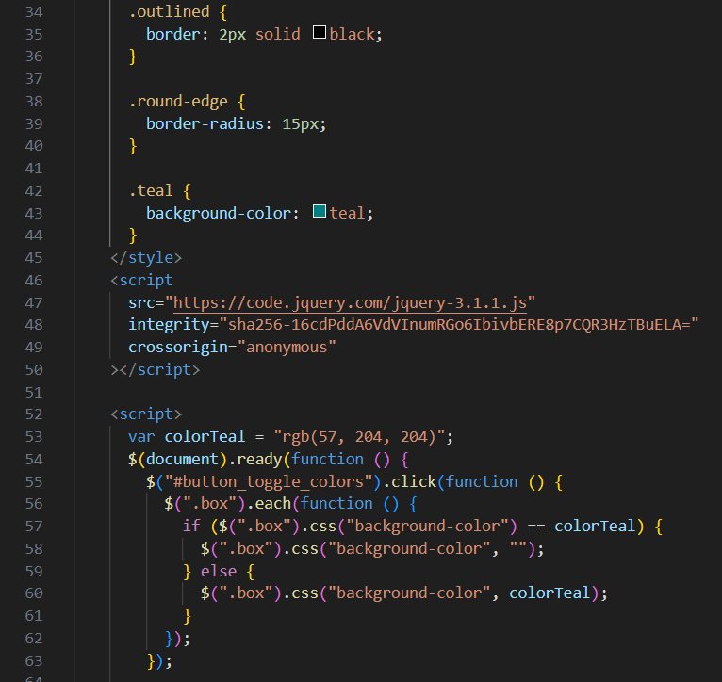

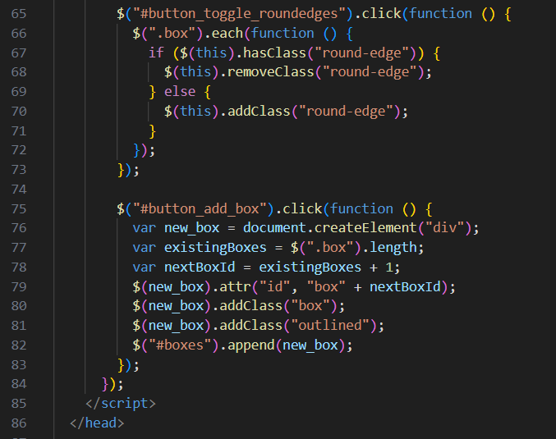

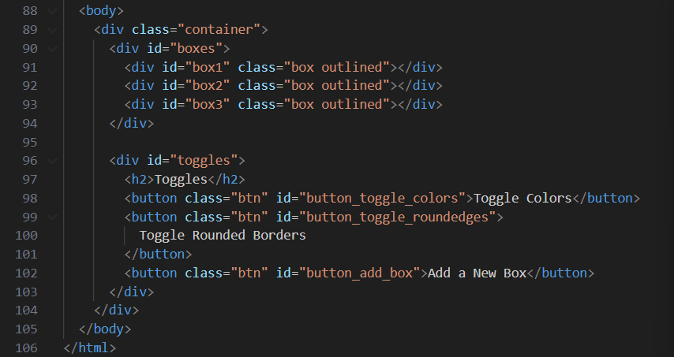

Task 3

The output:-

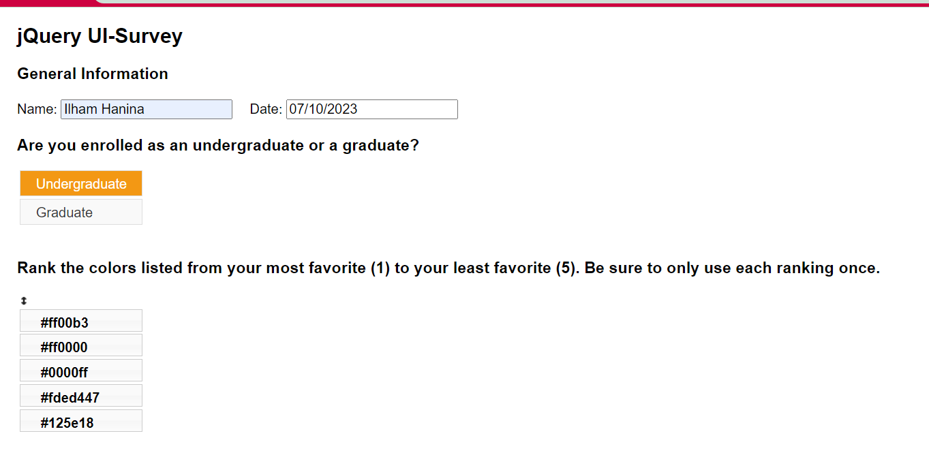

The codes:-

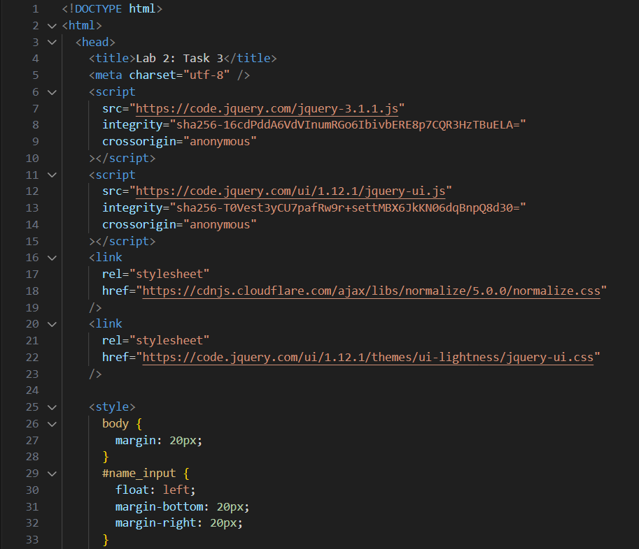

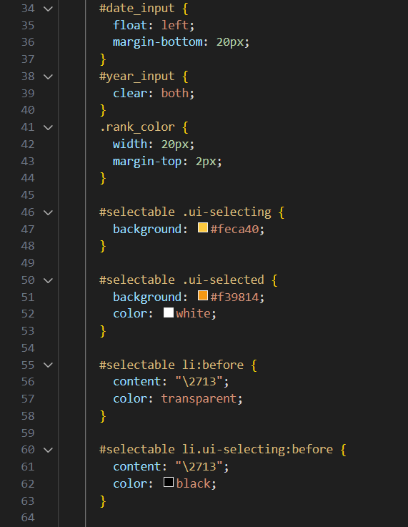

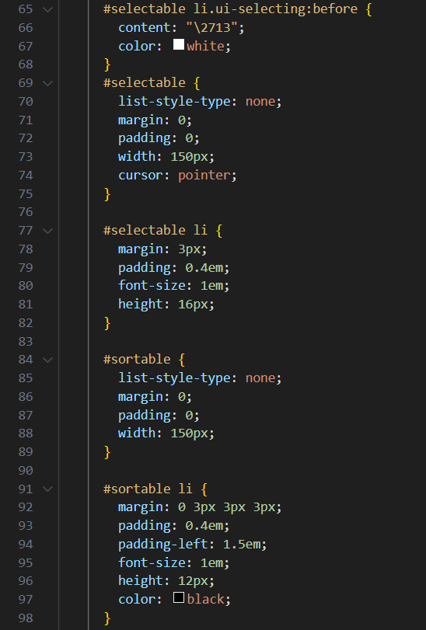

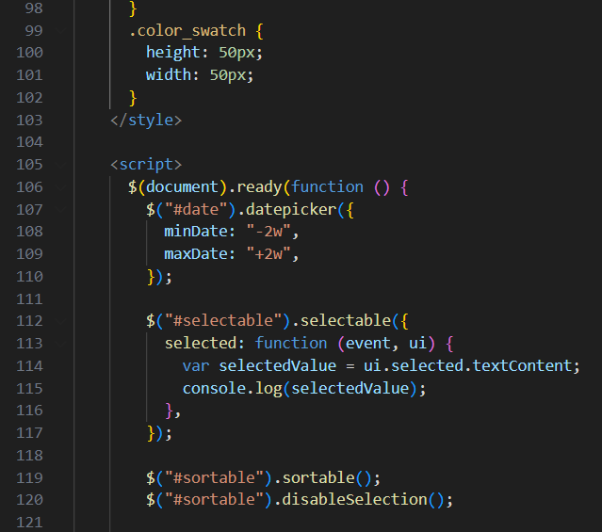

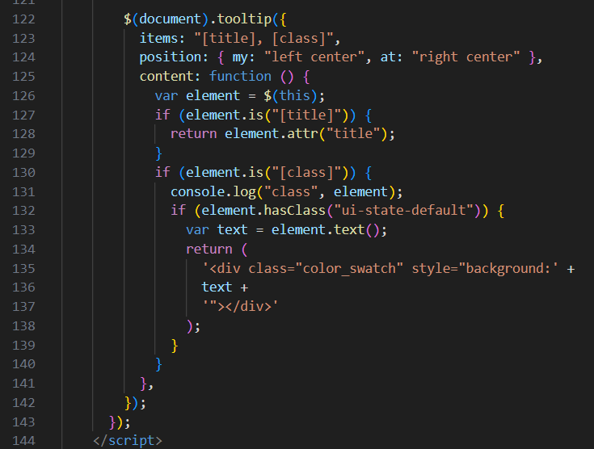

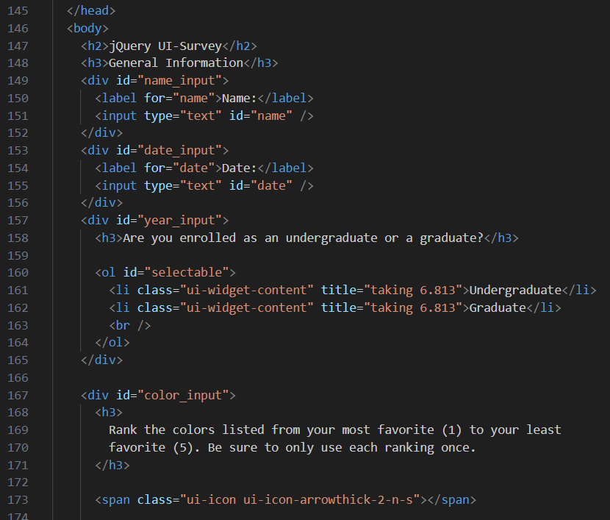 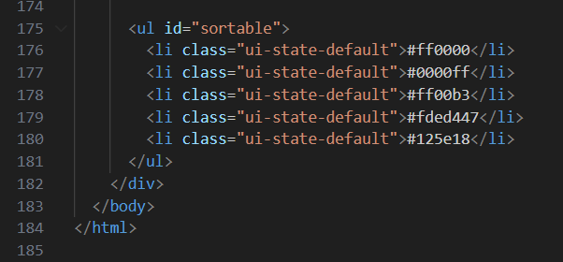

Task 4

The output :-

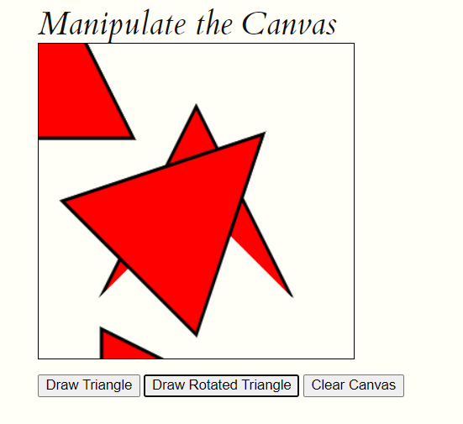

The codes:-

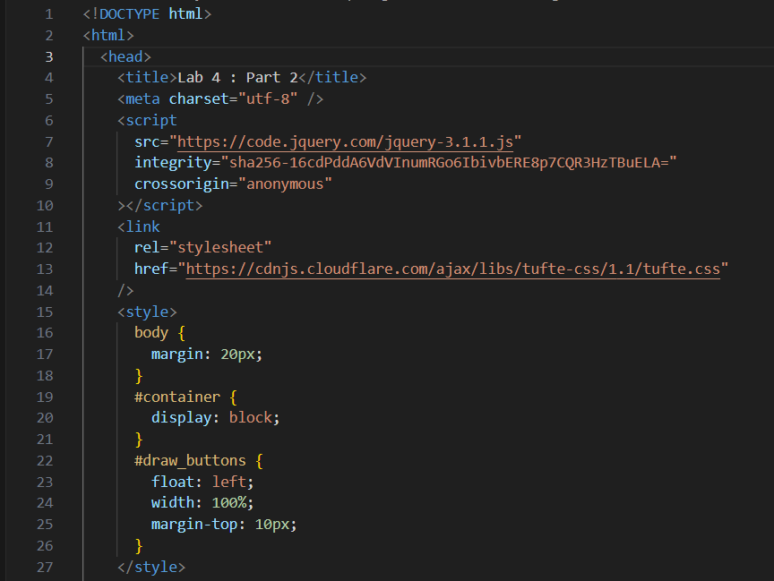

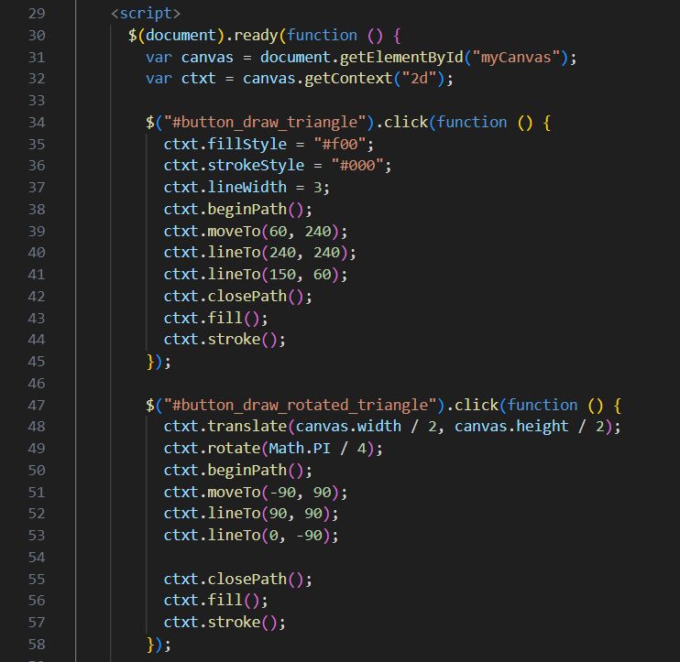

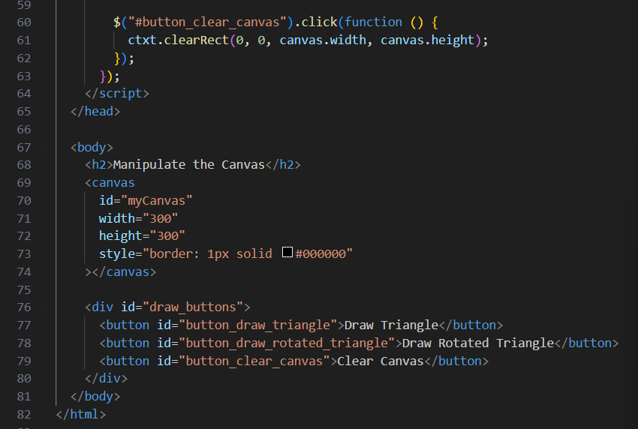

Link GitHub for the lab : <https://github.com/ilhamhanina/Code-Lab-CSM3103-S63762.git>